
American International University-Bangladesh (AIUB)
Department of Computer Science
Faculty of Science &Technology (FST)
Summer 25-26
PROJECT TITLE: SKILLSWAP
Software Requirement Engineering
Sec: A
Project submitted
By

ROJAN, MD ABU BOKOR SIDDIK (22-47890-2)
AFIA ANJUM ADRITA (23-51397-1)
MD. ABRAR HASAN (22-48347-3)

Checked By Industry Personnel

Name: Ifrat Jahan Chowdhury

Designation: Software Business Analyst

Company: Blinto LLC

Sign:

Date: 10/09/2026
Table of Contents
PROBLEM DOMAIN ......................................................................................... 3
Background to the Problem, Root Cause & Importance ................................... 3
Solution to the Problem, System Goals & Existing Studies .............................. 4
SOLUTION DESCRIPTION .............................................................................. 5
System Features & Scopes (Scopes 1 to 4) ........................................................ 5
5. User Story Table ............................................................................................ 6
6. Requirement Traceability Matrix (Functional & Non-Functional) ................ 7
UML DIAGRAMS ................................................................................................ 8
Use Case Diagram for SkillSwap Application ................................................... 8
Entity-Relationship (ER) Diagram .................................................................... 9
Class Diagram ................................................................................................... 10
3. TEST CASE ..................................................................................................... 11
Module-Based Index ......................................................................................... 11
User & Admin Authentication (TC-01-01 to TC-02-01) ................................. 12
Profile, Skill & Privacy Management (TC-03-01 to TC-05-01) ....................... 14
Matching Engine & Discovery (TC-06-01 to TC-06-02) .................................. 17
Exchange Lifecycle & Secure Reveal (TC-07-01 to TC-08-02) ....................... 19
Chat, Ratings & User Dashboard (TC-09-01 to TC-11-02) ............................. 21
Admin Operations & Analytics (TC-12-01 to TC-12-04) ................................. 24
Non-Functional Requirements Testing (TC-13-01 to TC-13-03) ...................... 26
Social Impact ........................................................................................................ 28
Development Plan with Project Schedule .......................................................... 29
4. Process Model & Comparative Analysis ....................................................... 29
Roles & Responsibilities .................................................................................... 30
4.1 Development Plan (SDLC Stages) .............................................................. 31
Sprint Boards Execution (Sprint 1 – Sprint 4) ................................................... 32
Marketing Plan .................................................................................................... 35
Short-Term, Long-Term & Continuous Marketing Strategies .......................... 35
Cost and Profit Analysis ..................................................................................... 36
COCOMO-Based Development Effort & Initial Investment ............................ 36
Monthly Operating Cost, Revenue Model & Profit Analysis ........................... 37
Break-Even Analysis & Three-Year Financial Projection ............................... 38
Risk Analysis, Exposure Matrix & Mitigation Strategy ................................... 39
Investment Justification, Assumptions & Limitations ..................................... 40
7. MEETING WITH SOFTWARE BUSINESS ANALYST ........................... 41
Meeting 1 (Trello & System Overview) ........................................................... 41
Meeting 2 (Sprint Review & Traceability) ....................................................... 42
Meeting 3 (Report Review & Final Verification) ........................................... 43
8. Reference ........................................................................................................ 45

- PROBLEM DOMAIN
  - Background to the Problem
Background Description
Contemporary skill acquisition relies on two disparate channels: expensive formal instruction (certified courses, commercial tutoring) and unorganized informal networks (social media groups, messaging boards). While formal programs present steep financial barriers for students and self-learners, informal channels lack structure, partner verification, and communication safeguards. Although non-monetary skill sharing occurs organically, the lack of dedicated digital infrastructure makes finding compatible partners difficult, uncoordinated, and risky. SkillSwap places this problem into context by serving as a dedicated web-based peer-to-peer (P2P) platform that formalizes reciprocal learning, enabling individuals to exchange expertise directly without financial transactions.
Root Cause of the Problem The core root cause is the infrastructural absence of a system tailored specifically for reciprocal, non-monetary skill exchange. Available digital platforms fall into two ineffective extremes:
- Commercial services that operate strictly on unidirectional, paid instructional models.

- Open social groups that lack algorithmic complementary matching ("Offer Skills" vs. "Wanted Skills"), contact-masking privacy controls, and verifiable transaction logs.
This infrastructural deficit prevents potential peer learners from discovering one another efficiently and safely.
Importance of Considering the Problem
Addressing this domain issue is vital for three key reasons:
- Educational Equity: Removes monetary constraints, allowing individuals to leverage their current proficiencies as currency to acquire new competencies.

- User Safety and Privacy: Protects personal identity by concealing sensitive contact information until both parties formally accept an exchange proposal.

- Systemic Trust and Accountability: Eliminates bad actors and unreliable participants through post-exchange rating mechanisms and visible Trust Scores, ensuring a reliable, long-term learning ecosystem.

  - Solution to the Problem
Proposed Solution & Appropriateness
SkillSwap proposes a web-based, reciprocal peer-to-peer (P2P) skill-exchange platform where users learn without financial transactions by trading knowledge directly.
- Core Solution: Users create dual-role profiles specifying "Offer Skills" and "Wanted Skills". The system uses an automated matching algorithm and location filtering to pair complementary users.
- Appropriateness: Solves the disorganization of social media groups by adding structured matching, privacy-protected communication (contact details revealed only upon request acceptance), and accountability through ratings and dynamic Trust Scores.
Feasibility:
- Economic: Zero payment gateway or micro-transaction processing overhead.
- Technical: Implemented using standard relational databases and responsive web architecture.
- Operational: Automated Trust Scores and administrative dashboards reduce manual moderation requirements.
Software Description, Benefits, and Goals
- Description & Purpose: A centralized knowledge-barter portal designed to democratize education by connecting complementary teachers and learners without monetary exchange.
- Benefits: Zero financial cost, strict contact privacy, personalized 1-on-1 pacing, and verified user credibility.
- Goals & Objectives: Deliver sub-second complementary partner search, provide 24/7 high availability, and maintain a safe platform via bilateral 1–5 star ratings.
Existing Studies & Software Solutions
- Existing Studies: Collaborative learning frameworks validate that reciprocal P2P instruction improves comprehension and engagement compared to passive learning. Time-banking studies confirm that non-monetary service trades sustainably foster community trust.

Existing Solutions:
- Paid MOOCs & Tutors (Coursera, Preply): Structured but locked behind financial fees and subscription paywalls.
- Online Social Groups (Facebook, Reddit): Cost-free but completely unorganized, lacking automated matchmaking, privacy safeguards, and reliability tracking.
- SkillSwap Differentiation: Merges the zero-cost advantage of community groups with the structured discovery, contact protection, and reputation tracking of dedicated educational software.

- SOLUTION DESCRIPTION

  - System Features
2.1.Scope 1
This scope covers user identity management and skill classification. The system will allow users to register, create detailed profiles, and explicitly define their expertise ("Offer Skills") and learning objectives ("Wanted Skills"). By structured categorization, the platform builds a searchable knowledge base of the community's capabilities.
Main features:
• User registration and secure login.
• Comprehensive profile management (Bio, Profile Picture).
• Dynamic Skill-set definition (Adding/Editing Offer & Wanted skills).
• Privacy settings for personal visibility.
2.2.Scope 2
This scope covers the discovery ecosystem. The system will employ matching algorithms to connect users based on complementary skill sets—linking those who offer what another wants. It allows users to navigate the community effectively through categorization and filtering tools.
Main features:
• Smart Matching algorithm (Suggesting compatible partners).
• Advanced Search functionality (by skill category or location).
• Filtering options for refined discovery.
• Interactive user profiles for previewing potential exchange partners.
3.Scope 3
This scope covers the lifecycle of an exchange request. It manages the communication flow between users from the initial request proposal to the final agreement. The platform ensures user safety and data privacy by restricting contact information disclosure until a request is mutually accepted.
Main features:
• Initiating and sending exchange requests.
• Real-time notification system for requests and status updates.
• Request decision workflow (Accept/Reject/Pending).
• Secure contact information revelation (only upon successful acceptance).
4.Scope 3
This scope covers community trust and performance tracking. To maintain high-quality interactions, the platform will implement a feedback mechanism. Both parties can rate their experience and provide reviews upon completing an exchange, which contributes to their overall Trust Score and reputation within the platform.
Main features:
• Rating and Review system (1-5 star scale).
• Calculation and display of user Trust Score.
• Exchange history and task status tracking (In-progress/Completed).
• User dashboard for monitoring overall engagement and reputation.

5. USER STORY TABLE
User | User story
Admin | As an admin, I want to manage user accounts so that I can maintain community safety and verify authenticity.
Admin | As an admin, I want to moderate reports and flagged profiles so that the platform remains secure for all users.
User | As a user, I want to define my "Offer" and "Wanted" skills so that the system can match me with the right partners.
User | As a user, I want to search and filter for specific skills so that I can find a tutor who fits my learning goals.
User | As a user, I want to send an exchange request to another person so that we can initiate a learning session.
User | As a user, I want to accept or reject requests so that I can manage my availability and schedule effectively.
User | As a user, I want to view my partner's contact details only after the request is accepted so that my privacy is protected.
User | As a user, I want to provide a rating and review after an exchange so that I can help build community trust.

6. REQUIREMENT TRACEABILITY MATRIX
6.1. Functional Requirements
The following section outlines the Requirement Traceability Matrix (RTM), which serves to map the project's functional and non-functional requirements to ensure alignment with the overall system objectives.
The system shall allow users to register and manage their secure profiles.
The system shall allow users to add and edit "Offer Skills" and "Wanted Skills."
The system shall provide an automated matching feature based on user skill profiles.
The system shall allow users to search and filter peers by skills or location.
The system shall enable users to send, accept, and reject exchange requests.
The system shall ensure contact information is hidden until a request is accepted.
The system shall allow users to rate and review their partners after an exchange.
The system shall display a trust score for users based on community feedback.
6.2. Non-Functional Requirements
The system should be available 24/7 for seamless community interaction.
The system should provide a modern, clean, and user-friendly interface.
The system should respond to user queries and matching requests within a reasonable time.
The system should protect user data and privacy through secure access controls.
The system should be scalable to accommodate an increasing number of users.
The system should maintain data accuracy and reliability throughout the exchange process.

  - UML Diagrams
- Use Case Diagram

- 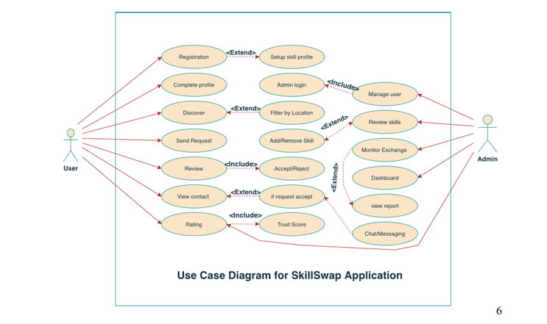ER-DIAGRAM:

- 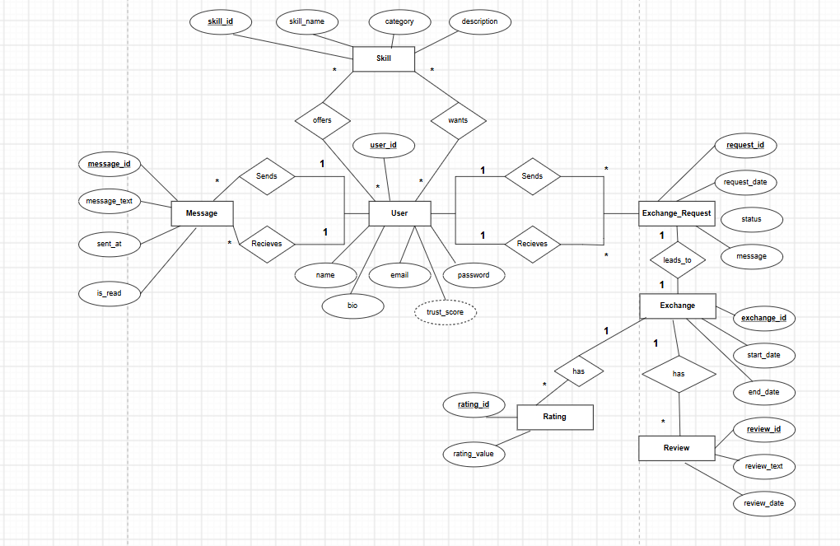

Class Diagram:

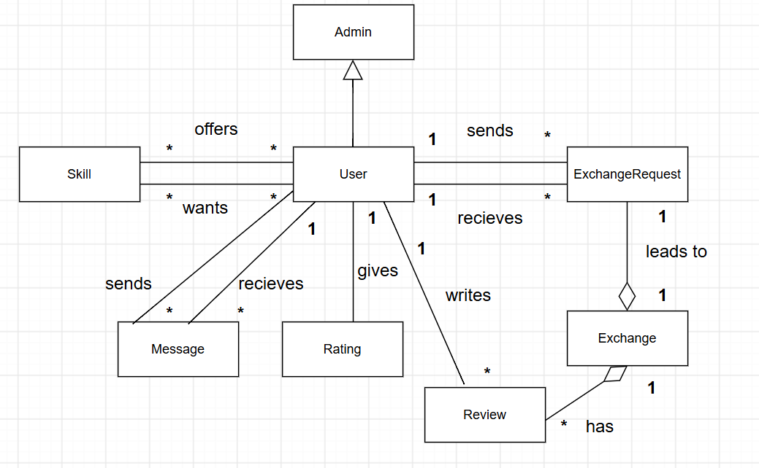

3. TEST CASE :

MODULE-BASED INDEX
Organized by functional module with total test cases per module
Module Name | Test Cases | IDs
User Registration & Authentication | 3 | TC-01-01 to TC-01-03
Admin Authentication | 1 | TC-02-01
Profile Management | 1 | TC-03-01
Skill Management | 2 | TC-04-01 to TC-04-02
Privacy Settings | 1 | TC-05-01
Matching Engine | 1 | TC-06-01
Search & Discovery | 1 | TC-06-02
Exchange Management | 2 | TC-07-01 to TC-07-02
Notifications | 1 | TC-08-01
Contact Information | 1 | TC-08-02
Communication (Chat) | 1 | TC-09-01
Ratings & Reviews | 1 | TC-10-01
Trust Score System | 1 | TC-10-02
Exchange History | 1 | TC-11-01
User Dashboard | 1 | TC-11-02
Admin User Management | 1 | TC-12-01
Admin Moderation | 1 | TC-12-02
Admin Monitoring | 1 | TC-12-03
Admin Analytics | 1 | TC-12-04
Non-Functional Requirements | 3 | TC-13-01 to TC-13-03
TOTAL: 20 Modules | 26 Test Cases
TEST CASE 1: Valid User Registration with Email
Test Case ID | TC-01-01
Module | User Registration & Authentication
Title | Valid User Registration with Email
Description | Test successful user registration with valid email and password
Precondition | User is on the registration page and not already logged in
Priority | High

Test Steps:
Step | Action | Test Data | Expected Result
1 | Click on "Sign Up" button | Email: test@example.com, Password: Secure@123 | Sign-up form displays
2 | Enter email address | test@example.com | Email field accepts input
3 | Enter password (min 8 chars, 1 uppercase, 1 digit) | Secure@123 | Password field masks input
4 | Confirm password | Secure@123 | Confirmation field accepts input
5 | Click "Register" button | Button click | Success message: "Account created successfully"
6 | Verify email in database | Database check | User record created with hashed password

Post Condition: User account is created; user redirected to login page
Status: ☐ PASS ☐ FAIL ☐ BLOCKED
Tester: Rojan Design Date: 20/08/2026
TEST CASE 2: Invalid Email Registration Rejection
Test Case ID | TC-01-02
Module | User Registration & Authentication
Title | Invalid Email Registration Rejection
Description | Test registration with invalid email format
Precondition | User is on the registration page
Priority | High

Test Steps:
Step | Action | Test Data | Expected Result
1 | Enter invalid email | invalidemail@ | Email field shows error
2 | Enter valid password | Secure@123 | Password accepted
3 | Click "Register" button | Button click | Error: "Invalid email format"

Post Condition: Registration is rejected; user remains on form
Status: ☐ PASS ☐ FAIL ☐ BLOCKED
Tester: Rojan Date: 20/08/2026
TEST CASE 3: Successful User Login
Test Case ID | TC-01-03
Module | User Registration & Authentication
Title | Successful User Login
Description | Test user login with correct credentials
Precondition | User account exists; user is on login page
Priority | High

Test Steps:
Step | Action | Test Data | Expected Result
1 | Enter email | test@example.com | Email field accepts input
2 | Enter password | Secure@123 | Password field masks input
3 | Click "Login" button | Button click | Dashboard loads successfully
4 | Verify session token | Check local storage | Auth token present in storage

Post Condition: User logged in; session active; redirected to dashboard
Status: ☐ PASS ☐ FAIL ☐ BLOCKED
Tester: Afia Date: 20/08/2026
TEST CASE 4: Admin Login with Valid Credentials
Test Case ID | TC-02-01
Module | Admin Authentication
Title | Admin Login with Valid Credentials
Description | Test admin login with correct admin credentials
Precondition | Admin account exists; user is on admin login page
Priority | High

Test Steps:
Step | Action | Test Data | Expected Result
1 | Enter admin email | admin@skillswap.com | Email field accepts input
2 | Enter admin password | AdminSecure@123 | Password field masks input
3 | Click "Login" button | Button click | Admin dashboard loads
4 | Verify admin role | Check user permissions | Admin role confirmed

Post Condition: Admin logged in; admin panel accessible
Status: ☐ PASS ☐ FAIL ☐ BLOCKED
Tester: Afia Date: 20/08/2026
TEST CASE 5: User Profile Setup with Bio and Photo
Test Case ID | TC-03-01
Module | Profile Management
Title | User Profile Setup with Bio and Photo
Description | Test profile setup with bio text and profile photo upload
Precondition | User is logged in; on profile setup page
Priority | High

Test Steps:
Step | Action | Test Data | Expected Result
1 | Enter bio text | I am a software engineer passionate about learning | Bio field accepts up to 500 chars
2 | Upload profile photo | File: profile.jpg (max 5MB) | File upload successful
3 | Enter full name | John Doe | Name field accepts input
4 | Select location | Dhaka, Bangladesh | Location dropdown works
5 | Click "Save Profile" button | Button click | Success: "Profile updated"

Post Condition: User profile completed with bio and photo
Status: ☐ PASS ☐ FAIL ☐ BLOCKED
Tester: Mahin Date: 20/08/2026
TEST CASE 6: Add Offer Skills to Profile
Test Case ID | TC-04-01
Module | Skill Management
Title | Add Offer Skills to Profile
Description | Test adding skills that user can offer to others
Precondition | User profile created; user on skill management page
Priority | High

Test Steps:
Step | Action | Test Data | Expected Result
1 | Click "Add Offer Skill" button | Button click | Skill form opens
2 | Select skill from dropdown | Python Programming | Skill selected
3 | Set proficiency level | Expert (5 years experience) | Level selected
4 | Add description | Can teach Python basics to advanced | Description added
5 | Click "Save Skill" button | Button click | Skill added to profile
6 | Add second skill | Web Development | Both skills visible in profile

Post Condition: Multiple offer skills added to user profile
Status: ☐ PASS ☐ FAIL ☐ BLOCKED
Tester: Rojan Date: 21/08/2026
TEST CASE 7: Add Wanted Skills to Profile
Test Case ID | TC-04-02
Module | Skill Management
Title | Add Wanted Skills to Profile
Description | Test adding skills that user wants to learn
Precondition | User profile created; on skill management page
Priority | High

Test Steps:
Step | Action | Test Data | Expected Result
1 | Click "Add Wanted Skill" button | Button click | Wanted skill form opens
2 | Select skill | Data Science | Skill selected
3 | Set desired level | Beginner | Level selected
4 | Add learning goal | Want to learn ML algorithms | Goal added
5 | Click "Save" button | Button click | Wanted skill saved
Post Condition: Wanted skills added to user profile
Status: ☐ PASS ☐ FAIL ☐ BLOCKED
Tester: Rojan Date: 21/08/2026
TEST CASE 8: Configure Profile Privacy Settings
Test Case ID | TC-05-01
Module | Privacy Settings
Title | Configure Profile Privacy Settings
Description | Test privacy control for profile visibility
Precondition | User logged in; on settings page
Priority | High

Test Steps:
Step | Action | Test Data | Expected Result
1 | Click "Privacy Settings" | Button click | Privacy options display
2 | Toggle "Show Profile Publicly" | Toggle ON | Profile visibility set
3 | Set "Who Can Message Me" | Select: Verified Users Only | Option selected
4 | Hide email address | Toggle OFF | Email hidden from others
5 | Click "Save Settings" | Button click | Settings saved

Post Condition: Privacy preferences saved and active
Status: ☐ PASS ☐ FAIL ☐ BLOCKED
Tester: Afia Date: 21/08/2026
TEST CASE 9: Smart Matching Algorithm - Get Recommendations
Test Case ID | TC-06-01
Module | Matching Engine
Title | Smart Matching Algorithm - Get Recommendations
Description | Test matching algorithm suggests compatible partners
Precondition | User with offer & wanted skills logged in; on discover page
Priority | High

Test Steps:
Step | Action | Test Data | Expected Result
1 | Navigate to "Discover" page | Button click | Discover page loads
2 | View recommended matches | System retrieves matches | Top 10 compatible users display
3 | Check match percentage | View match % | Each user shows match score (0-100%)
4 | Verify matching logic | User A offers what User B wants | Match % calculated correctly
5 | Click on matched user | User profile click | User profile shows with match reason

Post Condition: Relevant matches displayed with match percentages
Status: ☐ PASS ☐ FAIL ☐ BLOCKED
Tester: Mahin Date: 21/08/2026
TEST CASE 10: Search and Filter Users by Skill and Location
Test Case ID | TC-06-02
Module | Search & Discovery
Title | Search and Filter Users by Skill and Location
Description | Test search functionality with filters
Precondition | User on search page; multiple users in system
Priority | High
Test Steps:
Step | Action | Test Data | Expected Result
1 | Enter skill in search box | Python | Search results display
2 | Apply location filter | Select: Dhaka | Results filtered by location
3 | Apply proficiency filter | Select: Expert | Results filtered by level
4 | Sort results | Sort by: Highest Match % | Results sorted
5 | View search results | Result count | X matching users found

Post Condition: Filtered search results displayed correctly
Status: ☐ PASS ☐ FAIL ☐ BLOCKED
Tester: Mahin Date: 21/08/2026

TEST CASE 11: Send Exchange Request to Another User
Test Case ID | TC-07-01
Module | Exchange Management
Title | Send Exchange Request to Another User
Description | Test sending exchange request with message
Precondition | User logged in; viewing another user profile
Priority | High

Test Steps:
Step | Action | Test Data | Expected Result
1 | Click "Send Request" button | Button click | Request form opens
2 | Select offer skill | Python Programming | Skill dropdown shows user skills
3 | Select wanted skill | Web Development | Recipient skill selected
4 | Add message | I would like to learn web dev | Message field accepts text
5 | Click "Send Request" | Button click | Request sent; notification shown
6 | Check database | Query exchange_requests table | Request record created

Post Condition: Exchange request sent; recipient receives notification
Status: ☐ PASS ☐ FAIL ☐ BLOCKED
Tester: Rojan Date: 25/08/2026
TEST CASE 12: Accept or Reject Incoming Exchange Request
Test Case ID | TC-07-02
Module | Exchange Management
Title | Accept or Reject Incoming Exchange Request
Description | Test request approval/rejection workflow
Precondition | User has received exchange request; on notifications
Priority | High

Test Steps:
Step | Action | Test Data | Expected Result
1 | View incoming request | Click notification | Request details display
2 | Click "Accept" button | Button click | Status changes to ACCEPTED
3 | Verify contact reveal | Check if contact info shows | Requester contact details revealed
4 | Test reject flow (new request) | Click "Reject" | Status changes to REJECTED
5 | Verify contact hidden | Check contact info | Contact details remain hidden

Post Condition: Request status updated; actions triggered appropriately
Status: ☐ PASS ☐ FAIL ☐ BLOCKED
Tester: Rojan Date: 25/08/2026

TEST CASE 13: Real-time Notification on Request Status Change
Test Case ID | TC-08-01
Module | Notifications
Title | Real-time Notification on Request Status Change
Description | Test real-time notifications for request updates
Precondition | Two users: requester & responder; request pending
Priority | High
Test Steps:
Step | Action | Test Data | Expected Result
1 | Responder accepts request | Click Accept | Status changed in DB
2 | Check requester notification | Browser refresh/websocket | Real-time notification appears
3 | Notification shows status | View notification | Message: "Request accepted by [User]"
4 | Click notification | Click message | Navigates to exchange details

Post Condition: Real-time notification delivered to requester
Status: ☐ PASS ☐ FAIL ☐ BLOCKED
Tester: Afia Date: 25/08/2026
TEST CASE 14: Secure Contact Information Reveal After Acceptance
Test Case ID | TC-08-02
Module | Contact Information
Title | Secure Contact Information Reveal After Acceptance
Description | Test contact info visibility only after acceptance
Precondition | User sent request; request pending
Priority | High
Test Steps:
Step | Action | Test Data | Expected Result
1 | View request (pending) | Check request details | Contact info NOT visible
2 | Recipient accepts request | Accept action triggered | Database updated
3 | Refresh page/check updated status | Page reload | Contact info NOW visible
4 | Verify contact details | View phone/email | Contact: user@email.com or phone

Post Condition: Contact revealed only after mutual acceptance
Status: ☐ PASS ☐ FAIL ☐ BLOCKED
Tester: Afia Date: 25/08/2026
TEST CASE 15: Chat and Messaging Between Matched Users
Test Case ID | TC-09-01
Module | Communication
Title | Chat and Messaging Between Matched Users
Description | Test real-time chat between accepted exchange partners
Precondition | Two users with accepted exchange; on chat page
Priority | High
Test Steps:
Step | Action | Test Data | Expected Result
1 | Click on exchange partner | User selection | Chat window opens
2 | Type message | Hello, shall we start learning? | Message appears in input box
3 | Click "Send" or press Enter | Send action | Message sent; timestamp shown
4 | Verify message delivery | Check recipient browser | Message received in real-time
5 | Recipient types reply | Yes, let' schedule it | Reply appears immediately

Post Condition: Real-time chat established between users
Status: ☐ PASS ☐ FAIL ☐ BLOCKED
Tester: Mahin Date: 26/08/2026
TEST CASE 16: Rate and Review Exchange Partner After Completion
Test Case ID | TC-10-01
Module | Ratings & Reviews
Title | Rate and Review Exchange Partner After Completion
Description | Test rating (1-5 stars) and review submission
Precondition | User completed exchange; on rating page
Priority | High

Test Steps:
Step | Action | Test Data | Expected Result
1 | Click on exchange to rate | Exchange selection | Rating form displays
2 | Select star rating | Click 5 stars | Stars highlight (1-5)
3 | Enter review text | John was an excellent teacher! Very helpful and patient | Review field accepts text (max 500 chars)
4 | Click "Submit Review" | Button click | Success: "Review submitted"
5 | Verify in database | Query reviews table | Review record created with timestamp

Post Condition: Rating and review stored; visible on partner profile
Status: ☐ PASS ☐ FAIL ☐ BLOCKED
Tester: Rojan Date: 27/08/2026
TEST CASE 17: Trust Score Calculation and Display
Test Case ID | TC-10-02
Module | Trust Score System
Title | Trust Score Calculation and Display
Description | Test trust score calculation based on ratings
Precondition | User has received multiple reviews (5 reviews)
Priority | High

Test Steps:
Step | Action | Test Data | Expected Result
1 | Navigate to user profile | Profile click | Profile displays
2 | View Trust Score | Check score section | Trust Score visible (e.g., 4.6/5.0)
3 | Verify calculation | Check reviews | Score = Average of all ratings
4 | Check score badge | Visual indicator | Color codes: Green (4+), Yellow (3-3.9), Red (<3)
5 | View review count | Count badge | Total reviews: 5

Post Condition: Trust Score accurately calculated and displayed
Status: ☐ PASS ☐ FAIL ☐ BLOCKED
Tester: Rojan Date: 26/08/2026
TEST CASE 18: Exchange History and Status Tracking
Test Case ID | TC-11-01
Module | Exchange History
Title | Exchange History and Status Tracking
Description | Test exchange history log with status tracking
Precondition | User completed multiple exchanges; on history page
Priority | High

Test Steps:
Step | Action | Test Data | Expected Result
1 | Navigate to "Exchange History" | Menu click | History page loads
2 | View all exchanges | Page displays | List shows: Completed, In-Progress, Rejected
3 | Check exchange status | View status column | Status: COMPLETED, IN_PROGRESS, REJECTED, PENDING
4 | Click on exchange | Exchange selection | Details page shows: dates, ratings, messages
5 | Filter by status | Apply filter | List filtered by selected status

Post Condition: Exchange history displayed with proper status tracking
Status: ☐ PASS ☐ FAIL ☐ BLOCKED
Tester: Afia Date: 27/08/2026

TEST CASE 19: User Dashboard with Summary and Stats
Test Case ID | TC-11-02
Module | User Dashboard
Title | User Dashboard with Summary and Stats
Description | Test user dashboard displaying key metrics
Precondition | User logged in; on dashboard
Priority | High

Test Steps:
Step | Action | Test Data | Expected Result
1 | View dashboard | Dashboard loads | Key metrics displayed
2 | Check profile summary | Dashboard section | Bio, photo, Trust Score visible
3 | View statistics | Stats widget | Shows: Skills Offered, Skills Wanted, Completed Exchanges
4 | Check recent activities | Activity feed | Latest: New requests, Completed exchanges, Reviews
5 | View recommendations widget | Dashboard section | Top 5 recommended matches shown

Post Condition: Dashboard displays complete user overview
Status: ☐ PASS ☐ FAIL ☐ BLOCKED
Tester: Afia Date: 27/08/2026

TEST CASE 20: Admin Manage User Accounts (Ban/Approve)
Test Case ID | TC-12-01
Module | Admin Management
Title | Admin Manage User Accounts (Ban/Approve)
Description | Test admin user management functions
Precondition | Admin logged in; on user management page
Priority | High

Test Steps:
Step | Action | Test Data | Expected Result
1 | View all users | Admin dashboard | User list displays
2 | Search user by email | Search field | User found: john@example.com
3 | Click "Ban User" | Action button | Confirmation dialog appears
4 | Confirm ban | Click Confirm | User banned; status changed to BANNED
5 | Verify ban effect | User login attempt | Login fails: "Account suspended"
6 | Unban user | Click Unban | Status changed back to ACTIVE

Post Condition: User ban/unban action applied successfully
Status: ☐ PASS ☐ FAIL ☐ BLOCKED
Tester: Mahin Date: 28/08/2026
TEST CASE 21: Admin Review and Moderate Flagged Profiles/Skills
Test Case ID | TC-12-02
Module | Admin Moderation
Title | Admin Review and Moderate Flagged Profiles/Skills
Description | Test admin moderation of reported content
Precondition | Admin logged in; flagged items in queue
Priority | High

Test Steps:
Step | Action | Test Data | Expected Result
1 | Navigate to Moderation Queue | Menu click | Flagged items display
2 | View flagged profile | Click item | Profile review details show
3 | Review flag reason | Check reason field | Reason visible: "Inappropriate content"
4 | Click "Approve" to keep profile | Action button | Item removed; profile remains active
5 | Review another flagged item | Click item | Different flagged profile shows
6 | Click "Remove" to delete profile | Action button | Profile deleted; user notified

Post Condition: Moderation actions applied; queue updated
Status: ☐ PASS ☐ FAIL ☐ BLOCKED
Tester: Mahin Date: 30/08/2026

TEST CASE 22: Admin Monitor Exchange Activity and Metrics
Test Case ID | TC-12-03
Module | Admin Monitoring
Title | Admin Monitor Exchange Activity and Metrics
Description | Test admin activity monitoring dashboard
Precondition | Admin logged in; on activity monitor page
Priority | High

Test Steps:
Step | Action | Test Data | Expected Result
1 | View activity dashboard | Page loads | Activity metrics display
2 | Check live exchanges | Activity section | Shows: In-progress exchanges, count
3 | View user registrations | Timeline graph | Graph shows: Daily registrations
4 | Check request completion rate | Stats widget | Metric: 85% of requests lead to exchanges
5 | Filter by date range | Date picker | Activity filtered by selected dates

Post Condition: Activity monitoring dashboard functional
Status: ☐ PASS ☐ FAIL ☐ BLOCKED
Tester: Rojan Date: 03/09/2026

TEST CASE 23: Admin Reports and Analytics Dashboard
Test Case ID | TC-12-04
Module | Admin Analytics
Title | Admin Reports and Analytics Dashboard
Description | Test comprehensive analytics and reporting
Precondition | Admin logged in; on reports page
Priority | High

Test Steps:
Step | Action | Test Data | Expected Result
1 | Navigate to Reports | Menu click | Reports dashboard loads
2 | View user growth chart | Chart widget | Monthly user growth graph displays
3 | Check skill distribution | Skill report | Top 10 skills by frequency shown
4 | View engagement metrics | Metrics widget | Shows: Active users, avg exchanges/user, avg rating
5 | Generate custom report | Report builder | Select date range, metrics, export
6 | Export report | CSV/PDF button | Report downloaded successfully

Post Condition: Analytics reports generated and exported
Status: ☐ PASS ☐ FAIL ☐ BLOCKED
Tester: Afia Date: 05/09/2026

TEST CASE 24: NFR: Mobile-Responsive UI Design
Test Case ID | TC-13-01
Module | Non-Functional Requirements
Title | NFR: Mobile-Responsive UI Design
Description | Test responsive design on different screen sizes
Precondition | App deployed; test on multiple devices
Priority | High

Test Steps:
Step | Action | Test Data | Expected Result
1 | Test on desktop (1920x1080) | View page | Layout: 3-column grid; all elements visible
2 | Test on tablet (768x1024) | Resize/device mode | Layout: 2-column; navigation drawer appears
3 | Test on mobile (375x667) | Mobile device/emulation | Layout: 1-column; hamburger menu; touch-friendly
4 | Test navigation on mobile | Click menu | Hamburger menu opens/closes smoothly
5 | Test forms on mobile | Fill form field | Input fields sized for touch (min 44px)
6 | Check image scaling | View images | Images scale without distortion

Post Condition: UI responsive on all screen sizes (320px-1920px)
Status: ☐ PASS ☐ FAIL ☐ BLOCKED
Tester: Mahin Date: 04/09/2026

TEST CASE 25: NFR: Performance and Load Testing
Test Case ID | TC-13-02
Module | Non-Functional Requirements
Title | NFR: Performance and Load Testing
Description | Test system performance under load
Precondition | System deployed; load testing tools available
Priority | High

Test Steps:
Step | Action | Test Data | Expected Result
1 | Test page load time | Load home page | Load time < 2 seconds
2 | Test matching algorithm | Request matches for user with 100+ skills | Response time < 3 seconds
3 | Test search query | Search 50,000 users by skill | Results returned < 2 seconds
4 | Load test: 100 concurrent users | Simulate 100 users | System handles without errors
5 | Load test: 500 concurrent users | Simulate 500 users | Response time degrades gracefully; no crashes
6 | Monitor database performance | Check query times | Avg query time < 100ms

Post Condition: Performance metrics meet SLA requirements
Status: ☐ PASS ☐ FAIL ☐ BLOCKED
Tester: Mahin Date: 06/09/2026

TEST CASE 26: NFR: System Availability and Reliability
Test Case ID | TC-13-03
Module | Non-Functional Requirements
Title | NFR: System Availability and Reliability
Description | Test 24/7 availability and uptime
Precondition | System in production; monitoring in place
Priority | High
Test Steps:
Step | Action | Test Data | Expected Result
1 | Check system status | Status page | Status: All systems operational
2 | Verify uptime monitoring | Check uptime % | Target: 99.5% uptime (< 3.6 hours/month downtime)
3 | Test failover | Simulate server failure | Traffic redirects to backup; no user impact
4 | Test database replication | Check replica lag | Replication lag < 1 second
5 | Verify backup automation | Check backup logs | Daily backups completed successfully
6 | Test disaster recovery | Restore from backup | System restored within RTO (<1 hour)

Post Condition: System meets 99.5% availability requirement
Status: ☐ PASS ☐ FAIL ☐ BLOCKED
Tester: Afia Date: 08/09/2026

- Social Impact

SkillSwap introduces positive societal benefits by turning skill acquisition into an inclusive, decentralized community asset:
- Democratization of Education: By replacing financial fees with direct peer exchange, individuals from low-income or student backgrounds can acquire high-value skills without economic barriers.
- Knowledge as Community Currency: The system enables users to value their personal expertise and trade it as capital, fostering financial equity and self-reliance.
- Inclusive Peer Learning: Users act simultaneously as teachers and learners, breaking traditional hierarchical educational barriers and encouraging continuous, reciprocal learning.
- Enhanced Safety and Privacy: Unlike informal social networks, the platform safeguards user privacy by masking contact details until an exchange is mutually accepted, reducing spam and online vulnerabilities.
- Accountability and Trust: Transparent reviews and dynamic Trust Scores cultivate a culture of reliability, respect, and mutual accountability within the learning community.

- Development Plan with Project Schedule

4. PROCESS MODEL
We have chosen the Scrum Model for developing our software SkillSwap: A Peer-to-Peer Knowledge Exchange Platform.

Reasons:
1. Dynamic Requirements:
SkillSwap contains multiple interconnected features, including user profiles, skill management, smart matching, search and filtering, exchange requests, communication, ratings, reviews, and trust scores. Scrum allows the development team to adapt requirements and priorities as the project progresses.
2. Frequent Stakeholder Feedback:
The platform is designed for users who act as both skill providers and skill learners. Regular feedback is important to ensure that features such as skill discovery, exchange requests, privacy, and communication meet user expectations. Scrum supports continuous feedback throughout development.
3. Rapid Delivery and Iteration:
SkillSwap contains several independent but related features. Scrum allows the team to develop and test these features incrementally through short sprints. This makes it possible to identify problems early and improve the system in subsequent sprints.
4. Team Collaboration:
SkillSwap is being developed by a small team. Scrum promotes teamwork through sprint planning, daily progress monitoring, task assignment, testing, and sprint reviews. It also helps the team identify and resolve blockers quickly.

Comparison with Other Models:

Waterfall Model
- Follows a rigid, sequential development structure.
- Changes to requirements are difficult to accommodate after development begins.
- Not suitable for SkillSwap because the team may need to improve features based on testing and user feedback.

Incremental Model
- Develops the system in separate functional increments.
- .Provides less emphasis on continuous team collaboration and frequent stakeholder feedback compared with Scrum.
- May be less suitable when feature priorities need to change during development.

Agile XP (Extreme Programming)
- Strongly focuses on coding practices and technical development.
- Places comparatively greater emphasis on programming practices than project-level planning and management.
- Scrum is more suitable for SkillSwap because it provides a structured framework for sprint planning, task management, progress monitoring, and team coordination.

Roles & Responsibilities:
- Product Owner: Defines the product vision, prioritizes the product backlog, and ensures that SkillSwap features meet user and project requirements.
- Scrum Master: Facilitates Scrum activities, monitors sprint progress, removes blockers, and ensures that the team follows the Scrum process.
- Frontend Developer: Designs and develops the user interface for registration, profiles, skill management, discovery, exchange requests, dashboards, and other user-facing features.
- Backend Developer: Develops the server-side logic, APIs, database operations, authentication, skill matching, exchange-request workflow, and privacy-related functionality.
- QA Developer: Tests functional and non-functional requirements, performs integration and system testing, verifies user stories, and ensures that completed features work correctly.

4.1 DEVELOPMENT PLAN
The development of SkillSwap will follow the major activities of the Software Development Life Cycle (SDLC) using the Scrum framework.

1. Requirement Analysis
The team identifies and analyzes the requirements of SkillSwap, including user registration, profile management, Offer/Wanted skills, skill matching, search and filtering, exchange requests, contact privacy, ratings, reviews, and trust scores.

2. System Design
The team prepares the system architecture and necessary UML/database models. The design includes the user interface, database structure, user interactions, exchange-request workflow, and communication between system components.

3. Implementation
The development team implements the prioritized features selected for each sprint. Features are developed incrementally, allowing the team to complete and integrate different parts of the SkillSwap platform.

4. Testing
Each completed feature is tested to identify functional errors and integration problems. Test cases are executed for major functions such as registration, skill management, searching, exchange requests, privacy, rating, and review.

5. Integration
The developed modules are integrated into the complete SkillSwap system. The team verifies that features such as matching, exchange requests, communication, and trust-score calculation work together correctly.

6. Deployment
After the required features have been developed and tested, the completed SkillSwap application will be prepared for deployment and demonstration.

7. Maintenance
After deployment, identified bugs and usability issues can be fixed. Future improvements may include additional matching capabilities, improved communication features, and other community-oriented functions.
Sprint 1:
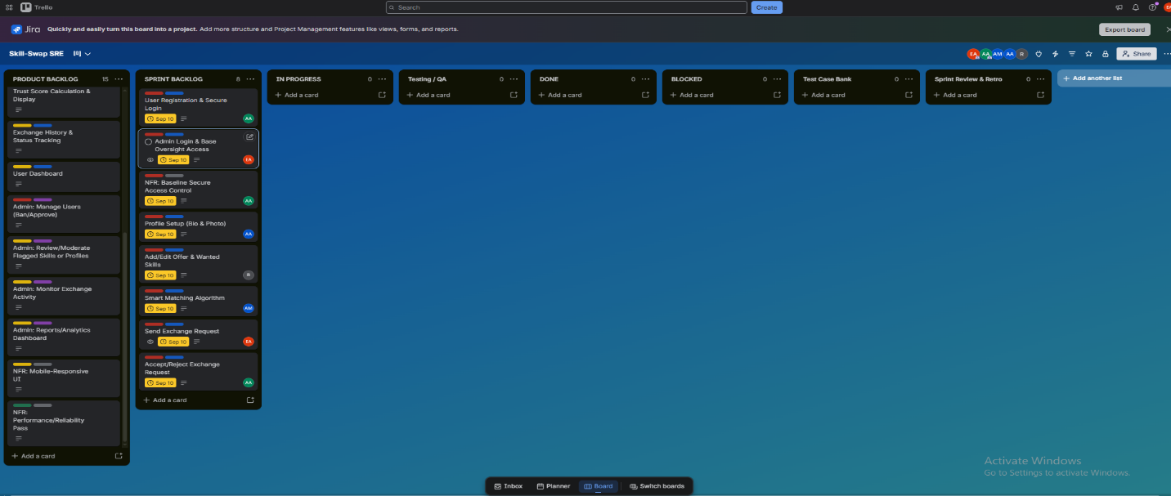
SPRINT 2:
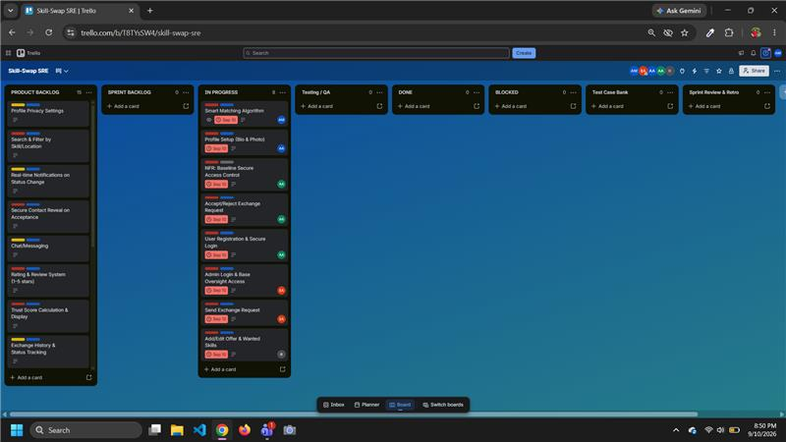
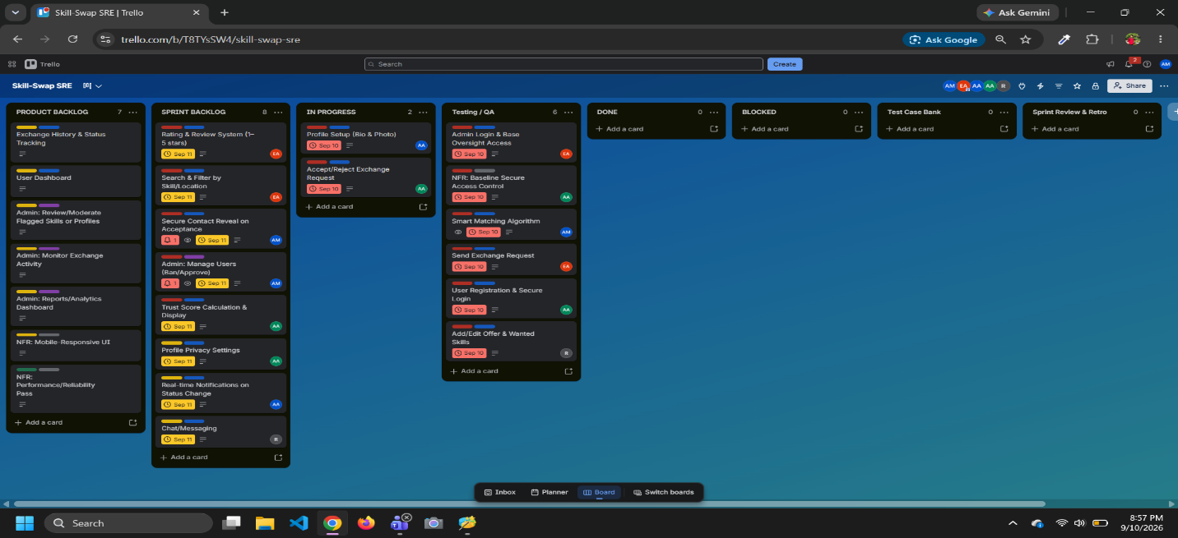

SPRINT 3:

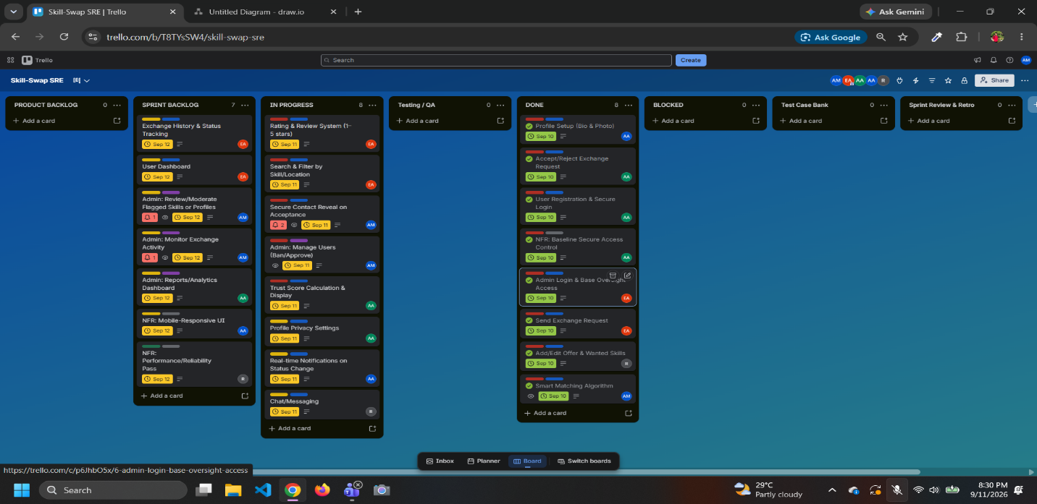

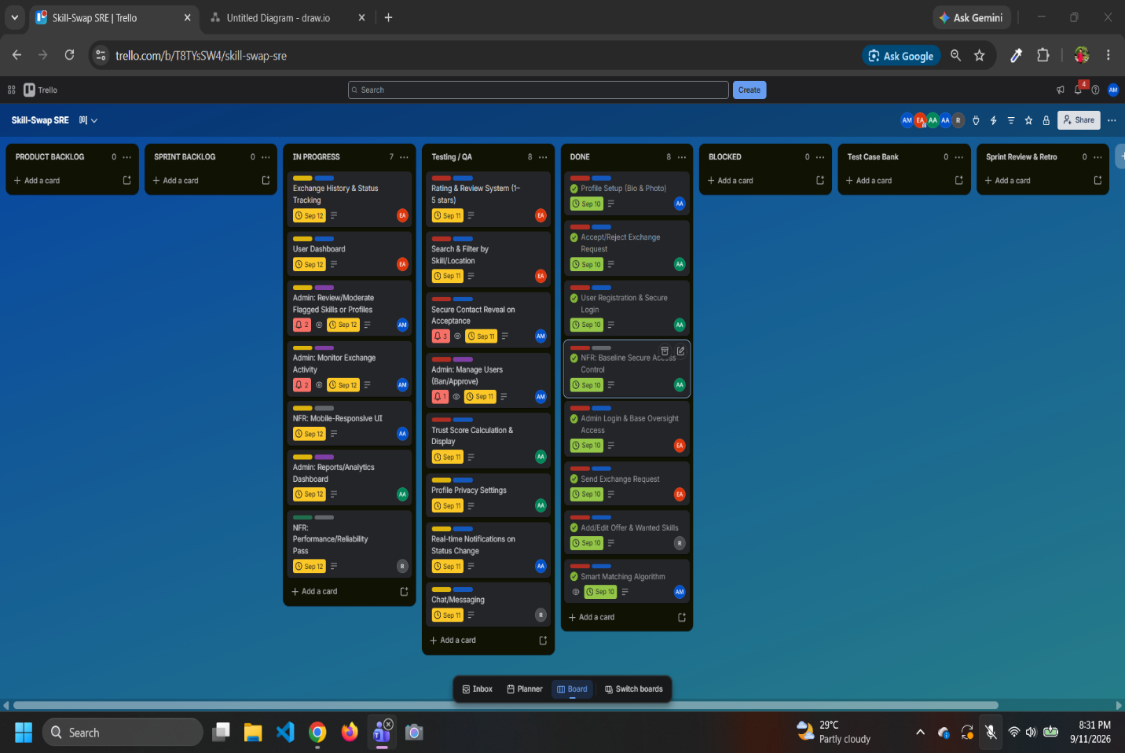

SPRINT 4:

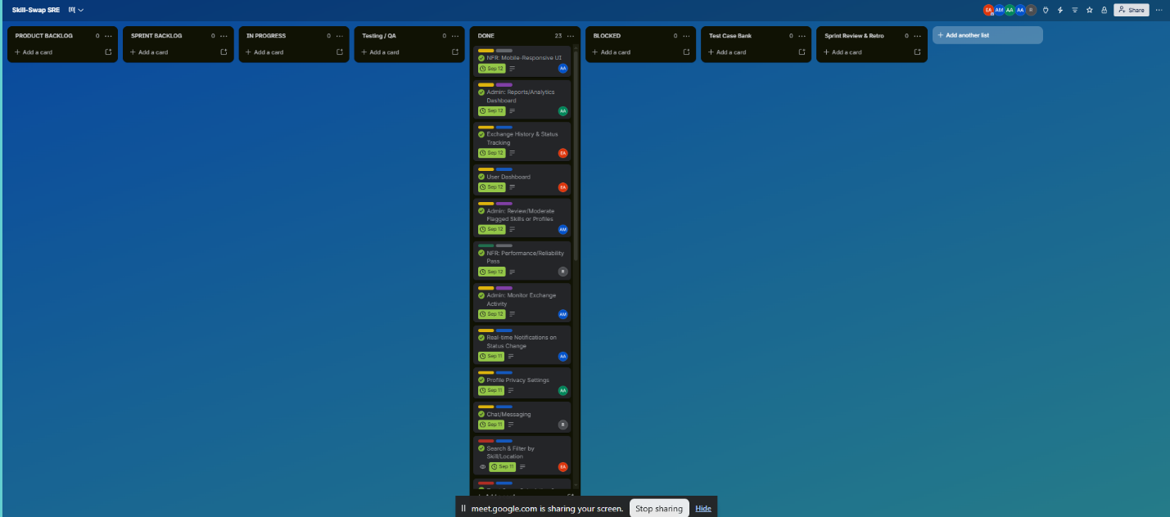

- Marketing Plan

The marketing strategy aims to build early liquidity, scale platform adoption, and introduce monetization without violating the core peer-to-peer exchange model.
Short-Term Plan (Months 1–6: Seeding & Acquisition):
- Deploy campus ambassador campaigns across universities and tech student clubs to capture initial peer-learning demand.
- Host targeted social media drives (LinkedIn, Discord, Facebook) promoting zero-cost skill bartering.
- Offer early-adopter profile badges for users completing their first verified exchange to seed initial community reviews.
Long-Term Plan (Months 7–24: Scaling & Monetization):
- Launch a "SkillSwap Pro" freemium model providing premium visibility, advanced search filters, and priority matching.
- Offer white-label B2B licensing for universities and corporate organizations to power internal employee/student mentoring programs.
- Introduce optional, paid skill-verification tests with partner institutes to boost profile Trust Scores.
Continuous Plan (Ongoing: Retention & Network Growth):
- Incentivize organic growth via a peer-referral mechanism rewarding users with platform perks. Feature weekly user success stories on social channels to reinforce community trust and authenticity.
- Implement an SEO-optimized blog focusing on self-learning, coding, and language exchange to maintain continuous organic search traffic.

- Cost and Profit Analysis
COST, PROFIT AND RISK ANALYSIS
The cost and profit analysis evaluates the financial feasibility of the proposed SkillSwap platform. The analysis considers software development effort, infrastructure, marketing, operational expenses, potential revenue sources, profitability, break-even, and major project risks.
Since SkillSwap is initially a student-developed web-based platform, two types of costs are considered: (1) estimated development value using COCOMO and (2) actual initial cash requirements for launching the platform.

6.1 COCOMO-Based Development Effort Estimation
The Basic COCOMO model is used to estimate the development effort for SkillSwap. SkillSwap is treated as an Organic Mode project because it is a relatively small web application developed by a small team using familiar technologies and without strict hardware or real-time constraints.
Estimated Software Size: 10 KLOC (10 thousand lines of code).
The estimate covers major components such as authentication, profiles, Offer/Wanted skills, matching, search and filtering, exchange requests, contact privacy, messaging, ratings, reviews, Trust Score, admin management, database, and API functionality.
For the Organic mode, the following Basic COCOMO equations are used:
Effort (E) = 2.4 × (KLOC)^1.05
Development Time (T) = 2.5 × (Effort)^0.38
Average Staff = Effort / Development Time
Calculation:
E = 2.4 × (10)^1.05 ≈ 26.93 Person-Months
T = 2.5 × (26.93)^0.38 ≈ 8.74 Months
Average Staff = 26.93 / 8.74 ≈ 3.08 persons
Parameter | Estimated Value
Software Size | 10 KLOC
Development Mode | Organic
Estimated Effort | 26.93 Person-Months
Estimated Development Time | 8.74 Months
Average Team Size | ≈ 3 Persons

The COCOMO result is an estimation benchmark for the economic value of professional development effort. It should not be interpreted as the amount of cash the student team must spend. The actual project can require much less cash because the team contributes its own development work.
6.2 Estimated Development Cost
For a commercial-value estimate, an assumed average development labor cost of 50,000 BDT per person-month is used. This assumption is used only to translate the COCOMO effort into an estimated labor value for financial analysis.
Development Cost = 26.93 × 50,000 = 1,346,500 BDT
Estimated economic development cost = 1,346,500 BDT.
6.3 Initial Cash Development Cost
Development Item | Estimated Cost (BDT)
Domain registration | 2,000
Cloud hosting/server | 15,000
Database and storage | 5,000
UI/UX resources | 5,000
Development/API services | 5,000
Testing and deployment | 5,000
Security and miscellaneous tools | 8,000
Total Initial Development Cash Cost | 45,000

6.4 Marketing Cost
Marketing Activity | Estimated Cost (BDT)
Social media advertising | 20,000
Campus ambassador activities | 10,000
Promotional materials | 5,000
Referral incentives | 10,000
Content creation | 5,000
Launch campaign | 10,000
Total Initial Marketing Cost | 60,000

Initial Cash Development Cost = 45,000 BDT
Initial Marketing Cost = 60,000 BDT
Total Initial Cash Investment = 45,000 + 60,000 = 105,000 BDT
6.5 Monthly Operating Cost
Operating Expense | Estimated Monthly Cost (BDT)
Cloud hosting/server | 10,000
Database/storage | 3,000
Maintenance and technical support | 15,000
Digital marketing | 15,000
Security/backups | 4,000
Miscellaneous expenses | 3,000
Total Monthly Operating Cost | 50,000

6.6 Revenue Model
SkillSwap will initially provide its core peer-to-peer exchange functionality for free. After establishing a sufficient user base, revenue can be generated through optional premium services, verification, organizational partnerships, and sponsored educational promotion.
- SkillSwap Pro: Premium features such as advanced search, enhanced profile visibility, priority matching, and additional profile features.
- Skill Verification: Optional paid skill assessments through suitable partner organizations.
- University/Organization Partnerships: Customized peer-learning and mentoring services for institutions and organizations.
- Sponsored Educational Promotion: Relevant educational organizations may promote suitable courses, events, or learning services.
6.7 Estimated Monthly Revenue
Revenue Source | Estimated Monthly Revenue (BDT)
SkillSwap Pro | 40,000
Skill Verification | 15,000
University/Organization Partnerships | 50,000
Sponsored Educational Promotion | 20,000
Total Monthly Revenue | 125,000

Justification: These are scenario-based estimates for academic feasibility analysis, not guaranteed revenue. They assume that SkillSwap has already achieved sufficient user adoption and has begun converting some users and organizations into paying customers.
6.8 Profit Analysis
Monthly Revenue = 125,000 BDT
Monthly Operating Cost = 50,000 BDT
Monthly Profit = 125,000 − 50,000 = 75,000 BDT
Estimated Annual Operating Profit = 75,000 × 12 = 900,000 BDT
6.9 Break-Even Analysis
Initial Cash Investment = 105,000 BDT
Target Monthly Operating Profit = 75,000 BDT
Break-Even Period = 105,000 / 75,000 ≈ 1.4 months
Therefore, once the platform reaches the assumed revenue level, the initial cash investment could be recovered in approximately 2 months. This is a theoretical payback period after reaching the target revenue level, not a claim that the platform will become profitable immediately after launch.
6.10 Three-Year Financial Projection
Year | Estimated Revenue (BDT) | Operating Cost (BDT) | Operating Profit (BDT)
Year 1 | 900,000 | 600,000 | 300,000
Year 2 | 1,500,000 | 780,000 | 720,000
Year 3 | 2,400,000 | 1,200,000 | 1,200,000
Total | 4,800,000 | 2,580,000 | 2,220,000

Justification: The projection assumes gradual growth rather than immediate achievement of the maximum monthly revenue scenario. Actual results will depend on user acquisition, subscription conversion, partnerships, marketing performance, and infrastructure costs.

6.11 Risk Analysis
Risk | Probability | Impact | Risk Level | Mitigation
Low initial user adoption | Medium | High | High | Campus ambassadors, referrals, social media campaigns
Insufficient skill matches | Medium | High | High | Matching algorithm, skill categories, search/filtering
User privacy/security issue | Low | Very High | High | Secure authentication, access controls, limited contact visibility
Fake profiles or misleading skills | Medium | High | High | Profile moderation, reporting, ratings and Trust Score
Server downtime | Low | High | Medium | Reliable hosting, backups and monitoring
Development delays | Medium | Medium | Medium | Scrum sprints, backlog prioritization and Trello tracking
High marketing cost | Medium | Medium | Medium | Campus/community marketing and referrals
Low premium conversion | Medium | Medium | Medium | Keep core features free and improve premium value
Negative community feedback | Low | High | Medium | Moderation, reporting and reputation mechanisms
Increased operating cost | Medium | Medium | Medium | Monitor infrastructure usage and optimize hosting

6.12 Quantitative Risk Exposure
Risk Exposure = Probability × Financial Impact
Example 1 – Low User Adoption: 0.30 × 200,000 = 60,000 BDT
Example 2 – Security/Privacy Incident: 0.10 × 500,000 = 50,000 BDT
Example 3 – Development Delay: 0.25 × 120,000 = 30,000 BDT
Example 4 – Server/Infrastructure Failure: 0.15 × 100,000 = 15,000 BDT
Combined Expected Risk Exposure = 60,000 + 50,000 + 30,000 + 15,000 = 155,000 BDT
Interpretation: The combined figure of 155,000 BDT is an estimated exposure based on assumed probabilities and impacts. It does not mean that SkillSwap will definitely lose this amount.

6.13 Risk Mitigation Strategy
- User Adoption: Use campus ambassadors, referral programs, social media campaigns, and university partnerships.
- Skill Availability: Encourage users to add multiple Offer and Wanted skills so that the matching pool becomes larger.
- Privacy: Keep contact information hidden until an exchange request is accepted.
- Trust: Use ratings, reviews, and Trust Score to improve community accountability.
- Security: Use authentication, authorization, secure password handling, and appropriate access controls.
- Development Delay: Use Scrum sprints and Trello to monitor tasks and identify blockers.
- Financial Risk: Start with low-cost infrastructure and increase spending only as the user base grows.
6.14 Investment Justification
Based on the above analysis, SkillSwap requires an estimated 105,000 BDT in initial cash investment for basic development infrastructure and initial marketing. The COCOMO analysis estimates approximately 26.93 person-months of development effort, demonstrating the economic value of the development work even though the student team can initially contribute this labor without equivalent cash expenditure.
The proposed revenue model uses SkillSwap Pro subscriptions, skill verification, university/organization partnerships, and sponsored educational promotion. Under the stated scenario assumptions, the platform can potentially generate approximately 125,000 BDT in monthly revenue after achieving sufficient market adoption, with an estimated 75,000 BDT monthly operating profit.
The major risks are user adoption, privacy/security, fake profiles, and development delays. These risks can be reduced through matching, moderation, privacy controls, ratings, reviews, Trust Score, and Scrum-based development.
Therefore, SkillSwap presents a potentially scalable and financially sustainable peer-to-peer learning platform, provided that the project successfully establishes a sufficiently large and active user community.
6.15 Assumptions and Limitations
- All financial figures in this section are estimates prepared for academic/project feasibility analysis.
- The 10 KLOC software-size estimate is an assumption for Basic COCOMO and should be revised if the final implementation size is substantially different.
- The 50,000 BDT/person-month labor rate is an assumed benchmark for translating COCOMO effort into economic development value; it is not a quoted salary or vendor price.
- Revenue figures are scenario assumptions and are not guaranteed market revenue.
- The break-even calculation applies after the platform reaches the assumed revenue/profit level.
- Actual costs will vary according to hosting, third-party services, user volume, marketing scale, and development requirements.

7.MEETING WITH SOFTWARE BUSINESS ANALYST (IFRAT JAHAN CHOWDHURY)

MEETING 1:

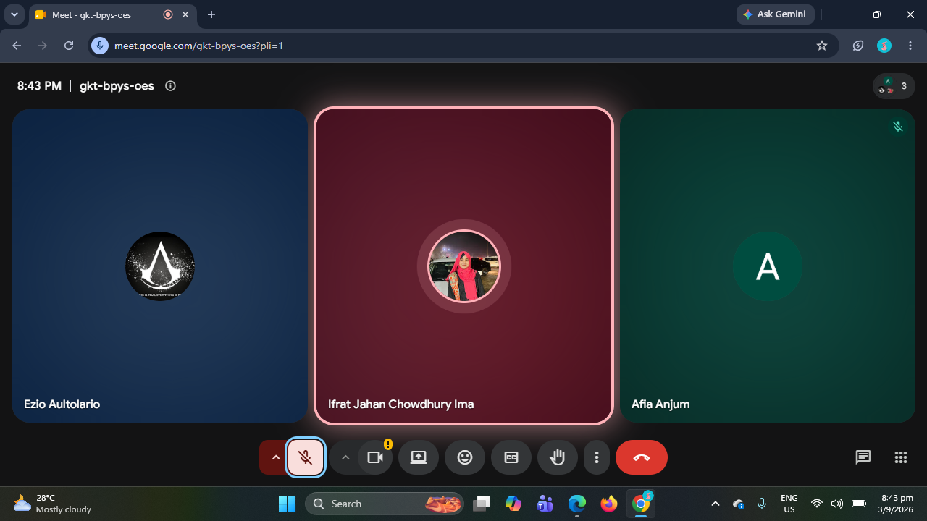

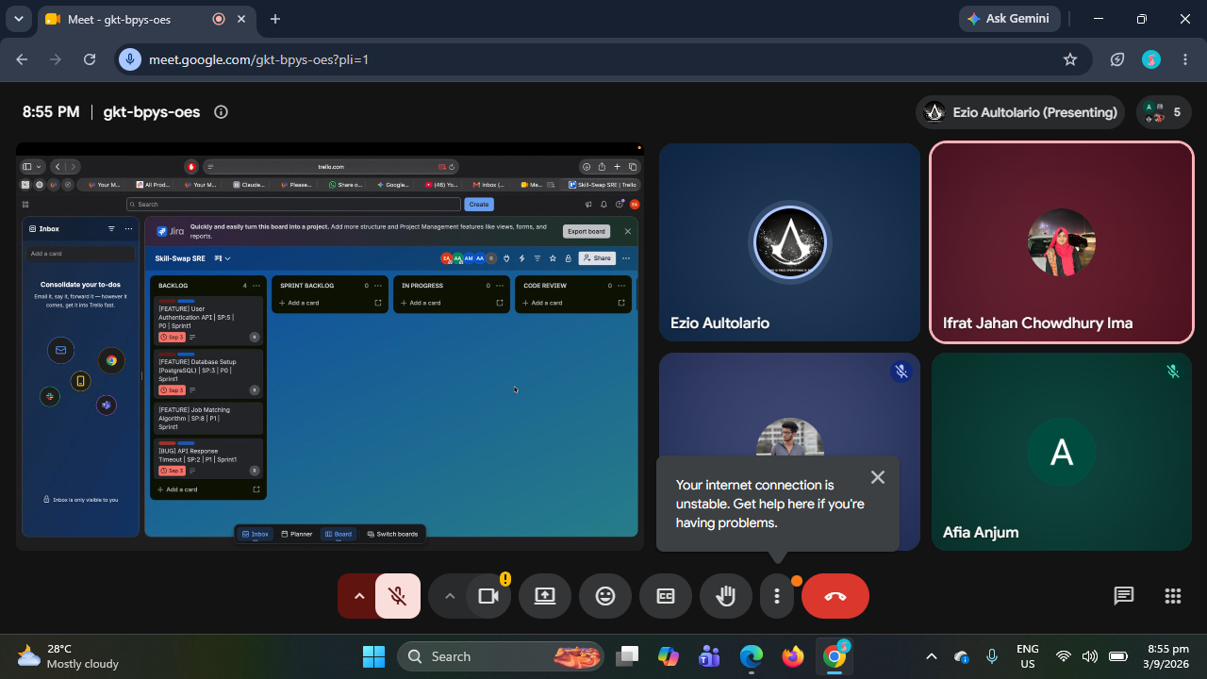

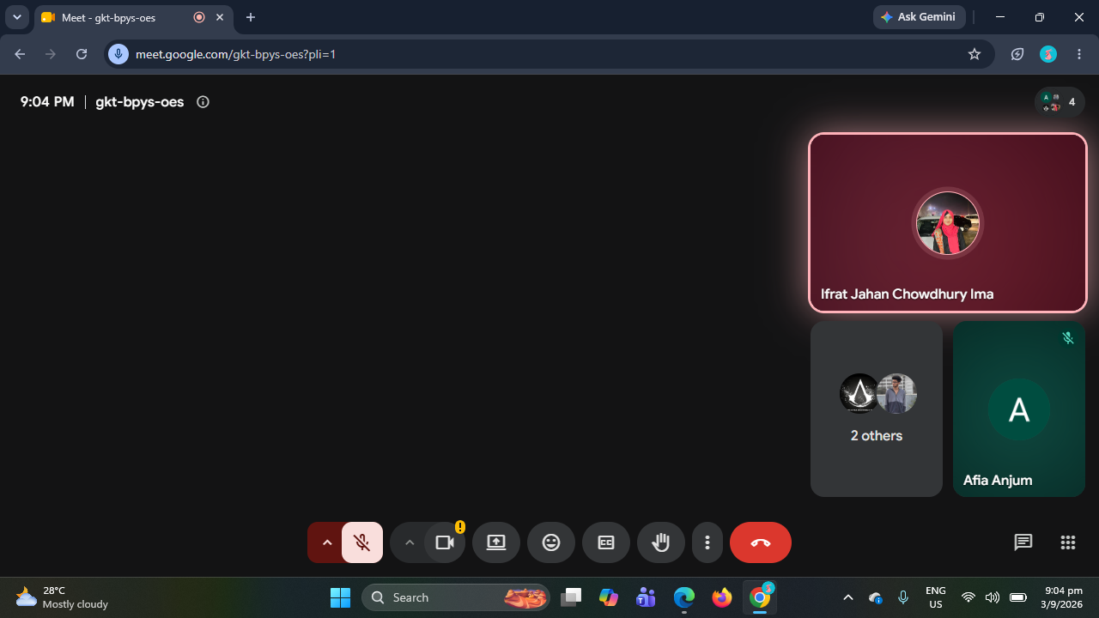

MEETING 2:

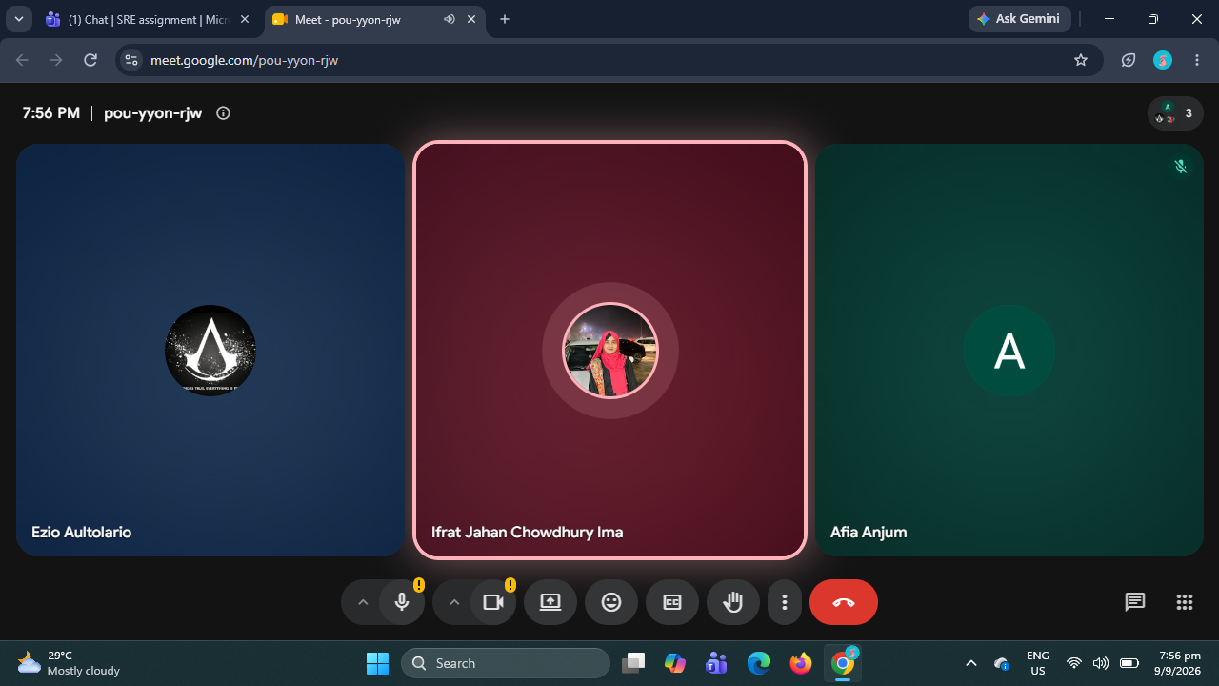

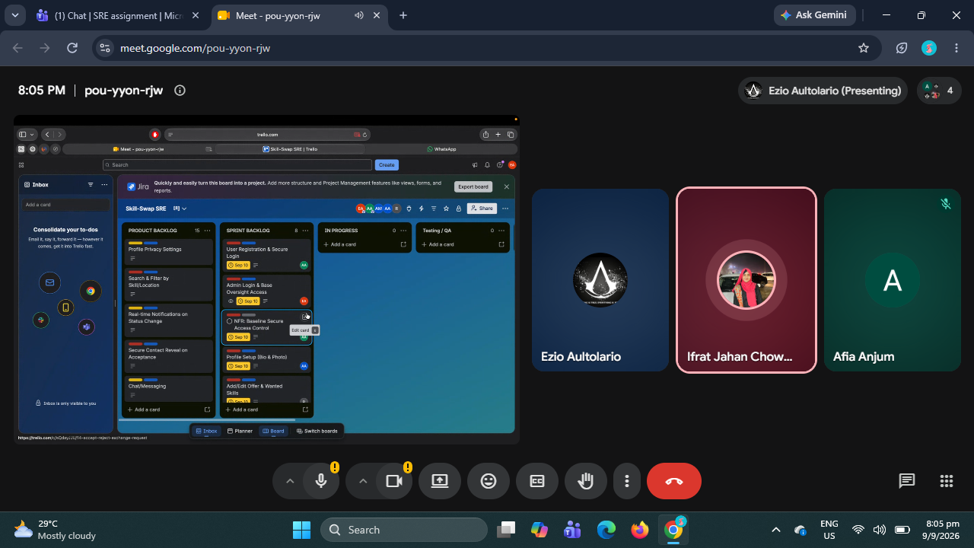

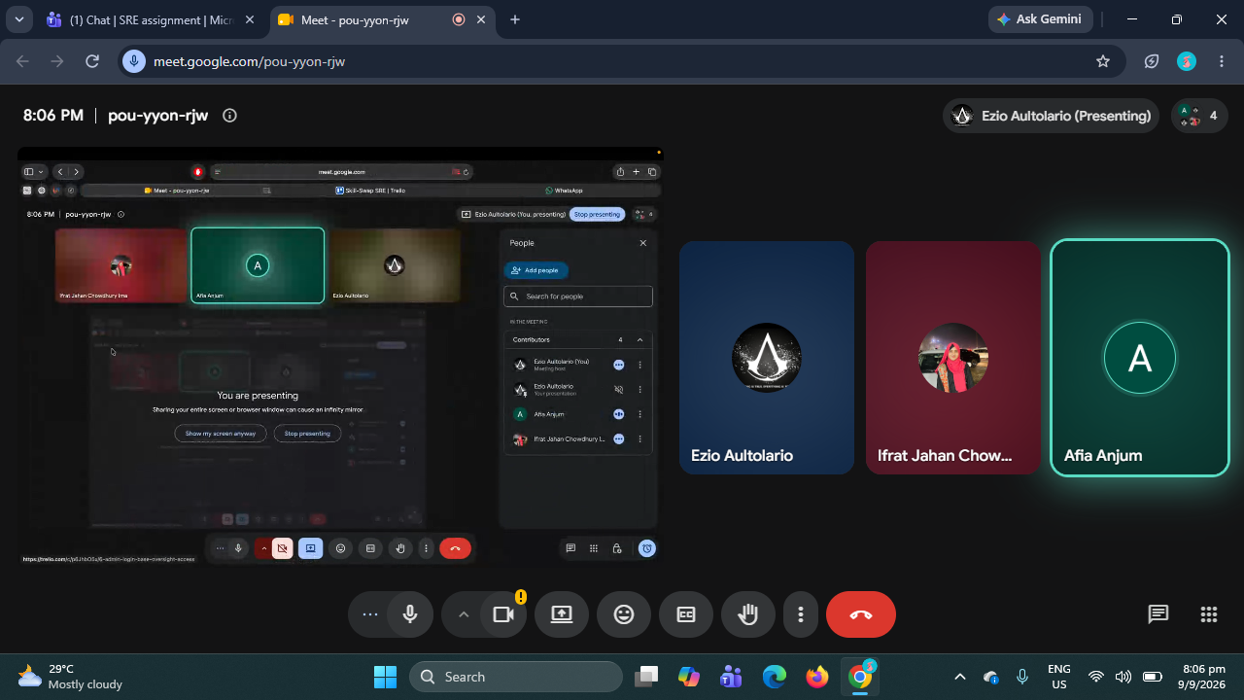

MEETING 3:

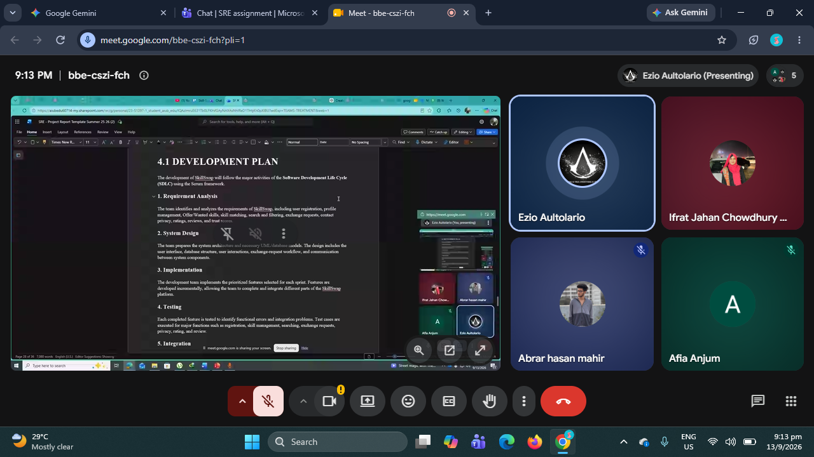

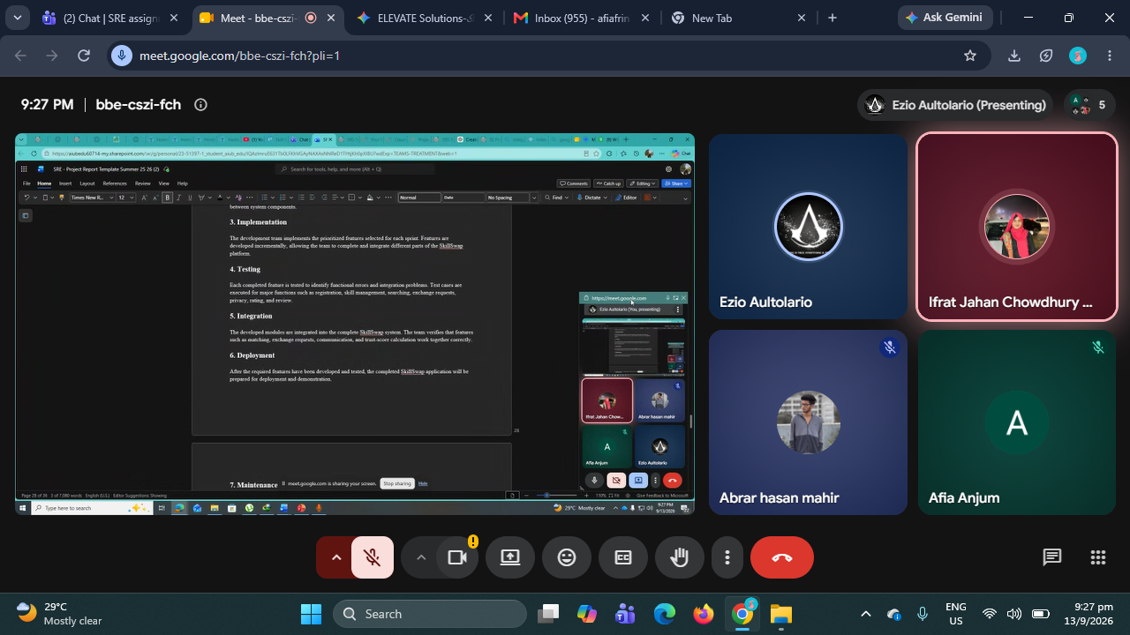

8.Reference
1. Pressman, R. S., & Maxim, B. R. (2020). Software Engineering: A Practitioner's Approach (9th ed.). McGraw-Hill Education.
2.Sommerville, I. (2016). Software Engineering (10th ed.). Pearson Education.
3.Vygotsky, L. S. (1978). Mind in Society: The Development of Higher Psychological Processes. Harvard University Press.
4.Boud, D., Cohen, R., & Sampson, J. (2014). Peer Learning in Higher Education: Learning from & with Each Other. Routledge.
5.Cahn, E. S. (2000). No More Throw-Away People: The Co-Production Imperative. Essential Books.
6.Fielding, R. T. (2000). Architectural Styles and the Design of Network-based Software Architectures (Doctoral dissertation). University of California, Irvine.
7.OWASP Foundation. (2021). OWASP Top 10: The Ten Most Critical Web Application Security Risks. Open Web Application Security Project.

